# Anatomy Of A Flight

Sending a balloon up to a high altitude is easy - put in enough gas for it to have lift, seal the neck, then let go. It will go up, a some point it will burst, and then the remains will come down. Somewhere.

To be useful though you will want to attach a payload containing whatever it is you want to send up - a camera, sensors, a scientific experiment - whatever. You will also need a means of tracking the flight, so you know where it lands - if you don’t know that then you are very unlikely to get the payload back, and you might as well have not bothered.

Oh, and you need a parachute, for hopefully obvious reasons.

That’s the flight itself, but the 2 or 4 hours that the balloon is in the air are probably the least important part of a process that begins many weeks before. Without proper preparation during that time then the flight will most likely fail. I have a list online that documents all the known failure modes for balloon flights, and believe me that list gets updated quite often when people find new and exciting methods that I’d not thought of. Please don’t burden me with more work updating that list! Be guided in your preparations by these key points:

* Do your research
* Do plenty of testing
* Do not rush

Research is vital. Read up on existing projects - many people run blogs or have web sites showing how they developed their flights. The [UKHAS wiki](http://ukhas.org.uk/) is invaluable and is probably the best single source of HAB information on the internet.

Testing is vital. If you're developing your own tracker hardware and/or software, then you have plenty more testing to do - does it work in the cold? does the software work across meridians? how long do the batteries last? Even if you buy a ready-made radio tracker, you need to test your tracking setup and skills. Don't leave that to the flight itself - it will all go terribly wrong.

**Do not rush.** My very first flight took 5 months from the idea to the execution. Overall it was a success although some things did go wrong. Not many flights are perfect in every way, so please do everything you can to make your flight the best it can be. **Do not set a launch date before you are ready**  - this is a tried and well tested method of ensuring failure.

Long before the flight itself, you should have completed all of these tasks:

* Locate a suitable launch site - one with a large clear area, preferably grassy, and not too far from a parking area (gas cylinders can be heavy). Balloons fly with the wind and that can easily mean directly into a tree, so a large field is ideal.
* Decide what you want to fly. Anything you fly must be safe - remember that it won’t necessarily land in a field so you should make sure it has no sharp edges, is surrounded by soft polystyrene foam, and contains nothing heavy or large and solid.
* Buy or build a GPS radio tracker, buy a radio receiver and aerial, and spend plenty of time becoming familiar with their operation.
* Fill in the CAA application form and send it in.

## CAA Permission

Every balloon flight UK aside from the very very small needs permission from the CAA. No permission means no launch. Permission is gained by sending in a completed application form (see your Links document) together with an OS map (scan or use Bing Maps) with the launch site highlighted.

The CAA request that you send the form in at least 28 days prior to launch, and I recommend that you do just that. However you will not know at that point if you will be able to launch on the date you requested. So I recommend the following:

1. Choose a launch site, If this is near an airport then you will either be denied permission, or it will come with restrictions as to what time you can launch and/or in what direction the balloon must fly after launch. I recommend you find a better launch site if this is likely!
2. Choose a date. Check online to see if there are any local airshows (these are, in my experience, the most likely reason for denying permission).
3. If the date is at a weekend, request both Saturday and Sunday
4. Fill in the form, and send to the CAA together with the required map.
5. Wait
6. About 6 days prior to launch, start checking the flight path predictions (see your Links document) and the ground wind predictions (Wunderground is good for this). Do this each day.
7. In light of the above predictions, if you think that the flight will be able to go ahead, then send an email to AUSOPS at the CAA, a few days before the flight, referencing your application and confirming that you believe the flight is likely.
8. If instead you can see that the flight won’t be able to happen, let the CAA know at least 2 days before the flight (if the flight is at the weekend let them know by Thursday at the latest), so they don’t waste time processing your request.
9. The last working day before launch, check the AIS site and/or notaminfo.com. Usually you will find out here that your NOTAM has been issued, before the CAA permission certificate comes through.
10. My experience is that permission comes through late in the afternoon. I realise that you may become nervous that nothing appears to be happening, but provided you sent in the confirmation email that I recommended then permission will be issued (this has been my experience anyway).
11. If permission does not arrive before the launch, do not launch. If the permission includes restrictions (e.g. on the wind direction) that you cannot meet, do not launch. Remember that obtaining permission is a critical safety step in the process.

## Purchasing

This is an approximate list, to use as a starting point. Don’t go buying anything until you have a good understanding of the entire project. Some items (e.g. parachute, balloon) depend on the weight of many of the other items, so these should be the last things you buy and not the first. I often get emails asking me for a list of items to buy, and it’s an impossible question to answer. Moreover, it’s the wrong question – it should be “what do I need to learn to make my flight safe and successful?”, and everything else should follow from that.

That said, the following should help you make your own lists.

**Payload**

* Balloon Tracker with GPS and radio aerials. e.g. Pi In The Sky
* (for the Pi In The Sky board) Model A+ Raspberry Pi
* (for the Pi In The Sky board if you want to add LoRa) LoRa HAT
* Batteries for tracker (ENergizer Lithium **only**)
* Payload materials:Expanded or Extruded Foam Polystyrene (sheets or ready-made ball or box or egg)
* UHU Por glue
* Duct Tape
* Waterproof label with your name / phone number / email address

**Flight Train**

* Balloon
* Parachute
* Cable Ties
* Braided Nylon Cord
* More Duct Tape

**Tracking Base Station**

* PC or laptop with internet connection
* Radio receiver (SDR or real one with audio cable)
* Aerial (colinear or 1/4-wave)
* Coax cable from aerial to radio

**Launch Kit**

* Ground sheet (tarpaulin)
* Filler Assembly (waste pipe, pipe insulation, silicone sealant, yet more duct tape)
* Water bottle (to check the neck lift)
* Water (for above)
* Scales (to measure weight of said bottle of water)
* Cable ties
* Duct tape
* Scissors
* Wire Cutters
* Latex gloves
* Cotton gloves

**Chase Car Kit**

* Magmount aerial
* Radio (real (preferred) or SDR)
* Laptop or netbook or tablet or phone with decoding software and “chase car” app and mapping (preferably offline)
* 3G connection (MiFi or a phone with 3G/WiFi tethering)
* Yagi aerial (for picking up a weak signal after the payload lands, or for direction-finding if it’s really weak)
* Wellies and/or walking boots
* Sat Nav
* Car Chargers for Phone/Tablet/Netbook/Laptop/MiFi.
* Real map

## Predictions

Even with permission, you should only launch with a safe flight path. This primarily means having a landing area that is well away from cities, large towns, airports or motorways. Remember that balloons may burst rather lower or higher than you planned for, due to manufacturing tolerances or your ability to fill the balloon with the correct amount of gas (see section on Filling below), so you should run predictions for early or late bursts as well as your planned burst altitude.

Also, do not plan a flight that lands close to the sea. No flight exactly follows the prediction. There are many variables such as the accuracy of the wind forecasts and (especially) the amount of gas put into the balloon, and as a rule of thumb I suggest you allow for a landing error of at least 5 mile radius, with an additional “distance from launch” error of 5% of the distance travelled. So a typical 100 mile flight would have a possible landing area of approx 10 miles long (in the distance travelled) by 5 miles wide (at right angles).

You can run a prediction online using the [CUSF Flight Predictor](http://predict.habhub.org/). This works up to about 6 days prior to the flight, but generally does not start to be accurate until about 3 days prior. It is worth running a prediction every day up to launch, to gauge how much they change from day to day – if they don’t change much then you will know that the prediction is quite predictable, which is good.

Another thing to check is how much the prediction changes from hour to hour during the launch day. Launches frequently (in fact, almost always, run late) and you should run a prediction for 1 hour after launch, as well as at the target launch time, to see if it changes much. A large change is bad because it makes the landing spot highly dependent on what time you launch.

As you run predictions, you will probably notice that the balloon direction changes throughout the flight. This is because the wind travels in layers with different layers travelling in different directions and/or at different speeds. Generally, ground level winds travel from west to east, but of course any direction is possible. Higher level winds tend, in the summer months, to travel from east to west meaning that your balloon will at some point reverse its direction. Here’s a typical example, with the flight travelling south, then east, then north, then west on the way up, and then turning in the opposite direction during descent:

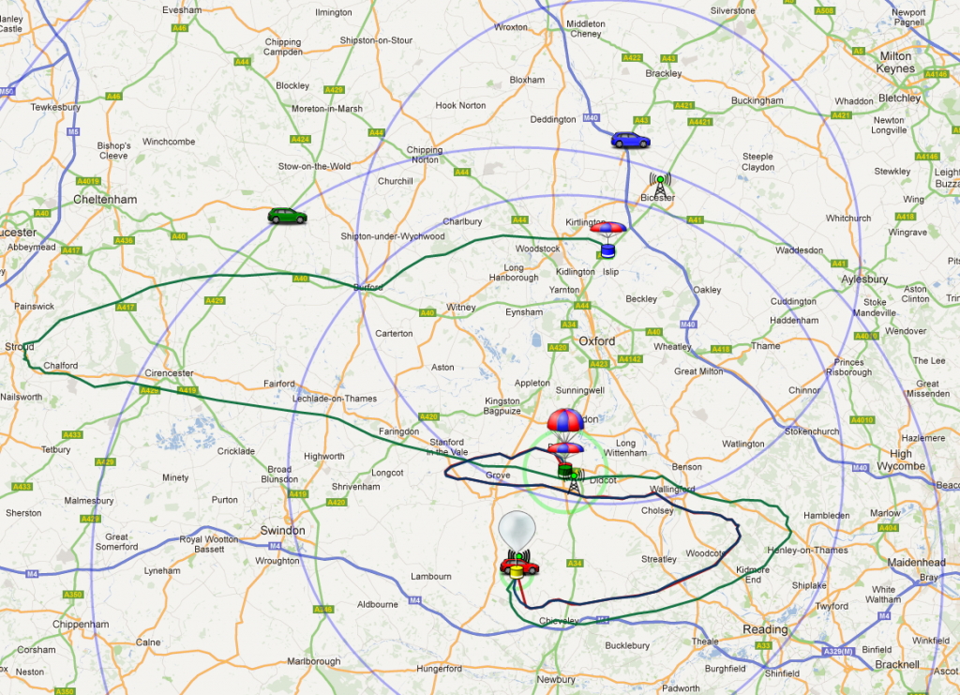

In the winter months, much depends on the jet stream. If you balloon hits this then it will be swept towards the continent at up to 200mph, making a UK landing impossible and recovery difficult.

**Remember to run a final prediction soon before your launch, so you have the most accurate data.**

## Balloons and Parachutes

Balloons come in various sizes and from 3 main manufacturers. For the widest choice and best service buy from Random Engineering (see Links document).

All the above parachutes have loops at the top for attachment to the balloon. Choose the size using the calculator on that page, aiming for a landing speed of 4 to 5 metres per second. You will need to know the payload weight, which you can estimate by adding together the weights of the heavier items and allowing 100g for the container and duct tape.

The larger the balloon, the higher the flight will go and, usually, the further it will land from the launch site. Anything above 25km will get good photographs, and 30km is a good figure to aim for. A typical size might be a 800g or 1000g balloon, but you should use the calculator to find out what size balloon you need for what altitude. Aim for an ascent rate of 5 to 6 metres per second, and remember that your payload weight should now include the weight of the parachute.

The calculator (see Links) will tell you several things, and not just the burst altitude:

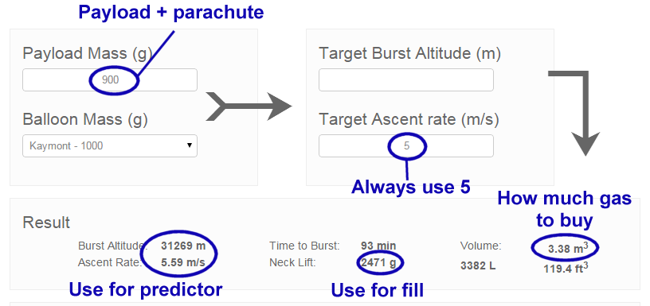

Payload Mass includes your parachute and the rigging (braided nylon cord). As a rough guide use 100g for both, but you can get the parachute weight from the store above, and you can weigh the cord.

Target Ascent Rate should be 5m/s. The calculator will then show a slightly different rate (see bottom left), and you can adjust your target for this to be 5m/s. Do not go lower than 5 as you risk the balloon not bursting.

Volume shows how much gas you need. Most balloons will need less than 3.6 cubic metres which is a BOC “T” cylinder, costing about £100. Try not to go above this figure as the next size up (“L”) is huge. If you do need more, than the Air Products N20 cylinder is a very good option as it’s not much heavier than the BOC T.

The Neck Lift tells you how much lift the balloon has when filled with the above volume. If you attached something of this weight to the balloon, then the balloon will hang in the air without going up or down.

## Balloon Neck Lift

“Neck Lift” is very important - get it wrong and your balloon may well end up “swimming with the fishes”. Newcomers seem to get confused about what this number means, so I should explain.

For simplicity, I will assume a 1kg balloon and a weight of 1kg for the payload and parachute. Obviously if you put the balloon on some scales, it will register (give or take a few grams) 1kg. Now let’s put some helium gas inside. As the helium fills the balloon, the balloon starts to displace the surrounding air. Because we are displacing air (which has a mass of over 1kg per cubic metre) with helium (which has a mass of about 10% of that), the more gas we put in the lighter the balloon becomes. At about 1 cubic metre of gas, the balloon will be light enough to just lift off the ground.

Of course at this point the balloon isn’t much use to us – we need it to lift the payload too! So we’ll put about 1 more cubic metre inside. Now we’ve displaced enough air to give us about 1kg of lift. Remember that our payload is 1kg, so if we closed off the balloon neck at this point and attached the payload, it’s going nowhere! We need more lift to take the payload up into the air. As it happens, we need about 1 more kg of lift and so about 1 more cubic metre of helium. Here’s a calculation for this example:

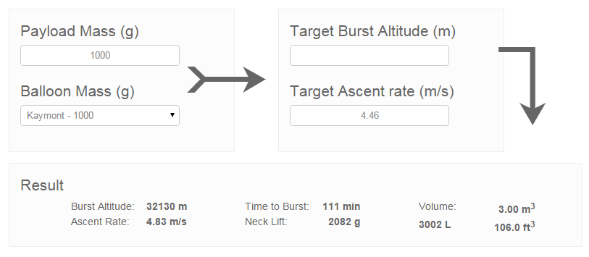

So that’s how the gas provides enough lift to send the balloon and payload up into the air, but how do we know we’ve put the correct amount of gas inside the balloon? That’s where the neck lift comes in. Remember that for the above example, we wanted 1kg to just lift the payload, and another 1kg to send the payload up at the right speed (5 metres per second), so that’s a total of 2kg. This is the “Neck Lift” and is 2.082kg in the screenshot above. Neck Lift is how much upward pull the balloon has. So now we know what it is, how to measure it?

## Filling

To fill a weather balloon, you need something to get the helium from the cylinder to the balloon. We call this a “filler” or “filling assembly”, and it’s basically a length of ordinary garden hose but with a fitting at each end.

The balloon opening (or “neck”) is a large diameter tube of relatively thick latex. It’s much too large to fit over the hose, so instead we fit the hose inside a larger tube (typically standard 40mm waste pipe which is sold by any DIY store). The gap between that tube and the hose needs to be filled with something that won’t leak gas. Expanded foam filler (also from a DIY store) is a common but rather messy choice. Or you can use a length of pipe insulation (also from … OK you know), sealed at each end with silicone sealant (guess…). Try this guide for how to make one.

The helium cylinder will come with a valve/regulator/filler that screws in to the top of the cylinder. There are 2 designs of these device, but for either you should be able to squeeze the hose over the opening and fix it down with a combination of duct tape and hose clips.

Suppose that the filler assembly (see below) weighs 300g, and you want a neck lift of 2kg. If you can attach something weighing 1.7kg (2.0 – 0.3) to the top of the balloon filler, then when the balloon has the desired neck lift (2kg) it will just be able to lift the filler (0.3kg) and added weight (1.7kg).

The one problem with the above is the wind. Any wind will try to move the balloon sideways. If you’re holding the balloon (to fill it) then the air going past the balloon will produce lift. If you measure the total lift then it will include this aerodynamic lift, so you can only measure the neck lift accurately when there is no wind. A slight wind is OK – carefully let go of the balloon and see if it goes up or down, before grabbing it quickly! Or wait for the wind to stop or at least calm down enough for you to let go briefly.

As a rule of thumb, if the predicted winds are stronger than 10mph, postpone the launch.